

**WEB LAB**

**Lab 11**

Syeda Ayesha Fatima

53953

Submitted to:

Ma’am Nayaab

**Task 1:**

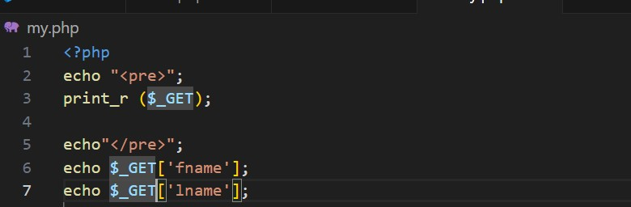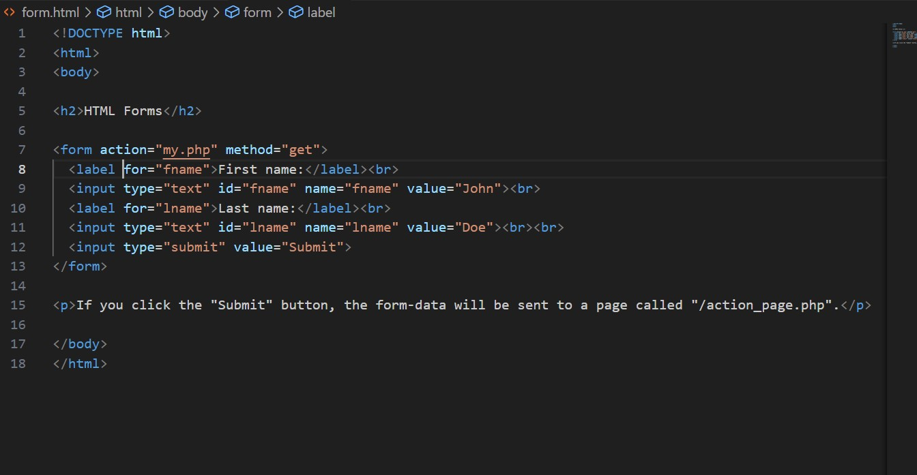

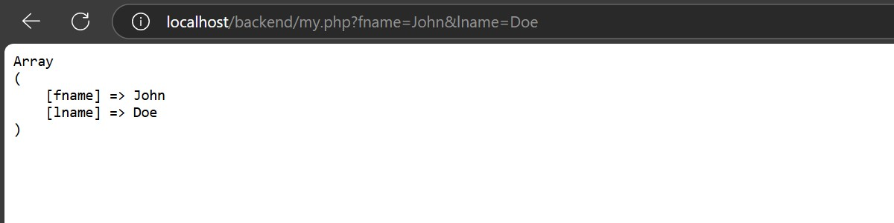

**Task 2:**

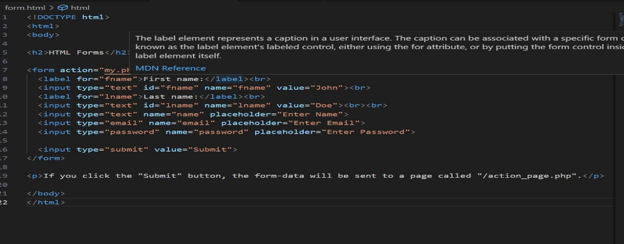

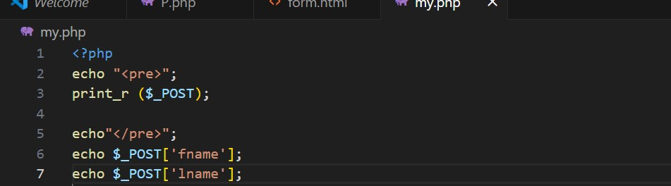

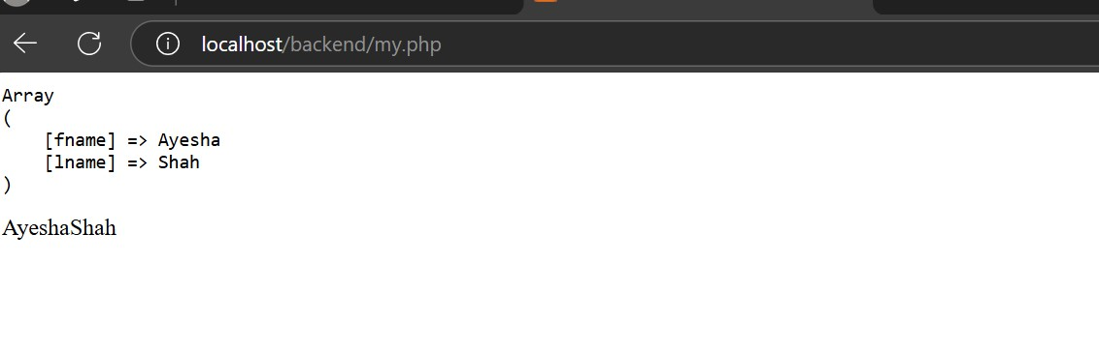

**Task 3:**

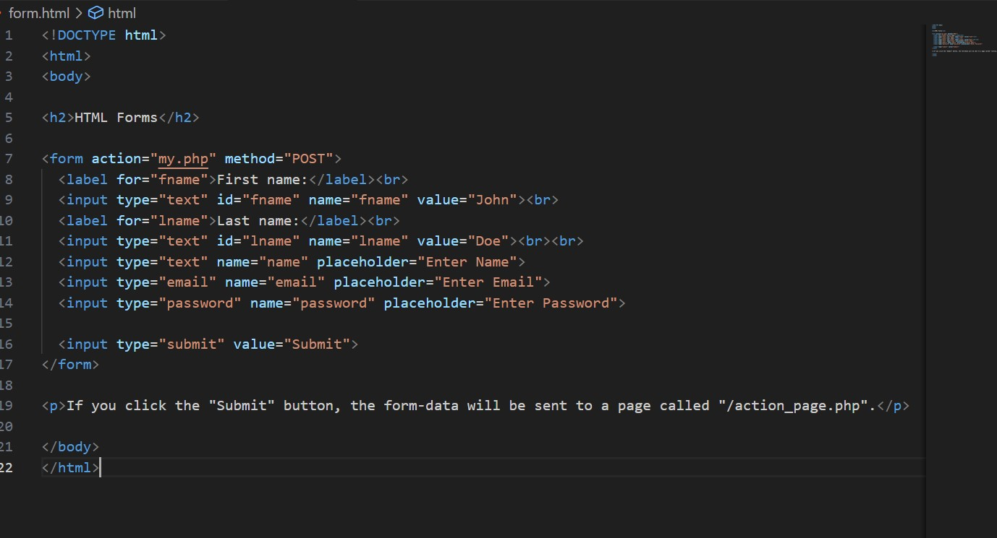

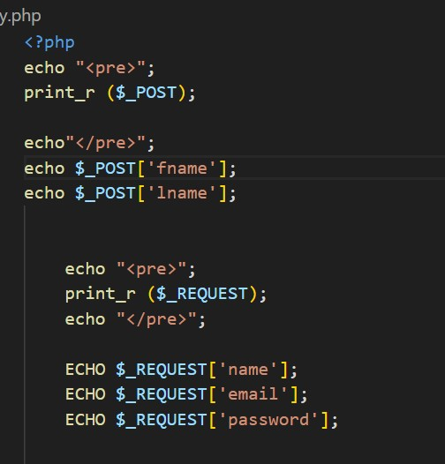

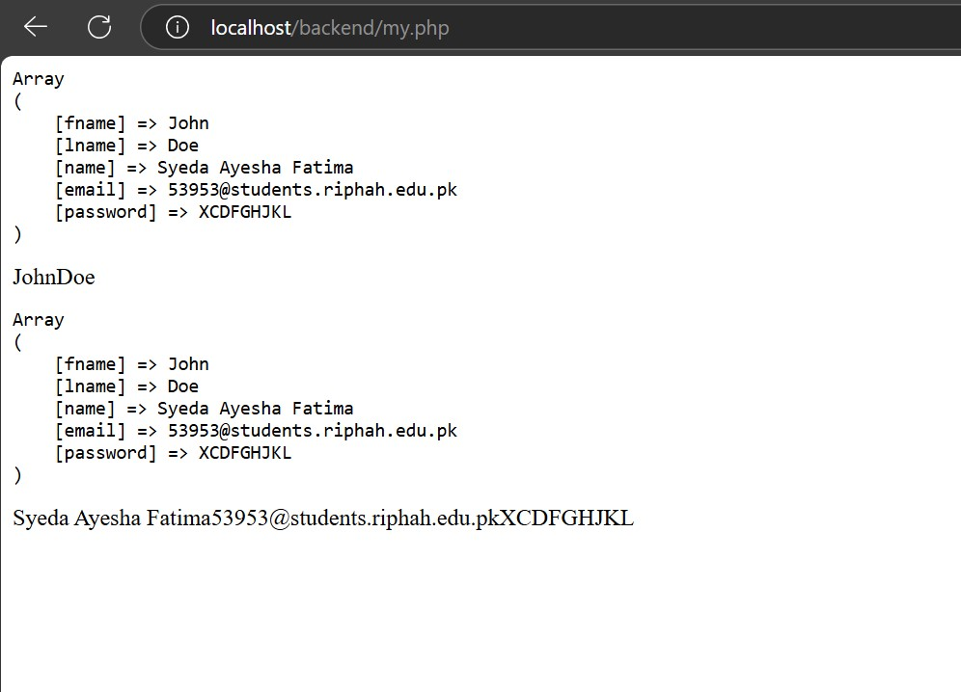

**Task 4:**





* The main difference between get and post is that in post data is hidden and in get it explicitly shown
* It is less secure (get) but more secure( post).

**Task 5:**



